# Laboratory 3

Title of the Laboratory Exercise: Database Design

1. Introduction and Purpose of Experiment

Students will design the database schema as per the ER diagram designed in the Laboratory 1 and 2.

1. Aim and Objectives

Aim

Objectives

At the end of this lab, the student will be able to

1. Experimental Procedure
2. Calculations/Computations/Algorithms

Creation of the database

DROP TABLE IF EXISTS PROJECT_EXHIBITION;

DROP TABLE IF EXISTS EXHIBITION;

DROP TABLE IF EXISTS PROJECT_STUDENT_REGISTER;

DROP TABLE IF EXISTS PROJEKT;

DROP TABLE IF EXISTS STUDENT;

DROP TABLE IF EXISTS STUDENT_LOGIN;

DROP TABLE IF EXISTS STAFF_LOGIN;

CREATE TABLE STAFF_LOGIN

(

    id INT(5) PRIMARY KEY AUTO_INCREMENT,

    user_name VARCHAR(20) UNIQUE KEY NOT NULL,

    hashed_password CHAR(60) NOT NULL

);

CREATE TABLE STUDENT_LOGIN

(

    id INT(5) PRIMARY KEY AUTO_INCREMENT,

    user_name VARCHAR(20) UNIQUE KEY NOT NULL,

    hashed_password CHAR(60) NOT NULL

);

CREATE TABLE STUDENT

(

    id INT(5) UNIQUE KEY NOT NULL,

    reg_no CHAR(12) PRIMARY KEY,

    name VARCHAR(30) NOT NULL,

    department ENUM('CSE', 'EEE', 'ECE', 'CIVIL'),

    course ENUM('B.Tech', 'M.Tech') NOT NULL,

    contact_no VARCHAR(10) NOT NULL,

*FOREIGN KEY*(id) *REFERENCES* STUDENT_LOGIN(id)

);

CREATE TABLE PROJEKT

(

    id INT(5) PRIMARY KEY AUTO_INCREMENT,

    project_leader_regno CHAR(12) UNIQUE KEY NOT NULL,

    project_name VARCHAR(100) UNIQUE KEY NOT NULL,

    mentor_name VARCHAR(30) NOT NULL,

    department ENUM('CSE', 'EEE', 'ECE', 'CIVIL') NOT NULL,

    category VARCHAR(30) NOT NULL

);

CREATE TABLE PROJECT_STUDENT_REGISTER

(

    project_id INT(5) NOT NULL,

    student_reg_no CHAR(12) NOT NULL,

*FOREIGN KEY*(project_id) *REFERENCES* PROJEKT(id),

*FOREIGN KEY*(student_reg_no) *REFERENCES* STUDENT(reg_no)

);

CREATE TABLE EXHIBITION

(

    room_id INT(5) PRIMARY KEY AUTO_INCREMENT,

    room_name CHAR(20) UNIQUE KEY NOT NULL,

    capacity INT(5) NOT NULL

);

CREATE TABLE PROJECT_EXHIBITION

(

    room_id INT(5) NOT NULL,

    project_id INT(5) UNIQUE KEY NOT NULL,

    table_no INT(5) *CHECK* ( table_no **>** 0 AND table_no **<** ( SELECT **\*** FROM EXHIBITION WHERE EXHIBITION.*room_id* **=** room_id LIMIT 1 ) ),

*FOREIGN KEY*(room_id) *REFERENCES* EXHIBITION(room_id),

*FOREIGN KEY*(project_id) *REFERENCES* PROJEKT(id)

);

Inserting data into the table

INSERT INTO `STUDENT_LOGIN` (`id`, `user_name`, `hashed_password`) VALUES

(1, '17ETCS002159', '$2b$10$uVRx4ogFBi0owMljpvEilONnd9wWOMtrpgVwqw2Mw8.aNmo6yEU1u'),

(2, '17ETCS002122', '$2b$10$ATp9qxsPWBsOUXDAB1YvK.yTLi4GK1mzpIHBCfSOCQwtxLU/52Pk2'),

(3, '17ETCS002168', '$2b$10$3cfBMD3yRi3YJk.fFGrNY.Yx1RRonj4z2cqgOe2fgZ78yNaqRxFkC');

INSERT INTO `STUDENT` (`id`, `reg_no`, `name`, `department`, `course`, `contact_no`) VALUES

(2, '17ETCS002122', 'Prachi Poddar', 'CSE', 'B.Tech', '9856523658'),

(1, '17ETCS002159', 'Satyajit Ghana', 'CSE', 'B.Tech', '7892137665'),

(3, '17ETCS002168', 'Shikhar Singh', 'CSE', 'B.Tech', '9852145896');

INSERT INTO `PROJEKT` (`id`, `project_leader_regno`, `project_name`, `mentor_name`, `department`, `category`) VALUES

(2, '17ETCS002159', 'KrishiAI', 'Chaitra S', 'CSE', 'DL');

INSERT INTO `PROJECT_STUDENT_REGISTER` (`project_id`, `student_reg_no`) VALUES

(2, '17ETCS002159'),

(2, '17ETCS002122'),

(2, '17ETCS002168');

INSERT INTO `EXHIBITION` (`room_id`, `room_name`, `capacity`) VALUES

(1, 'A201', 60);

1. Presentation of Results

Now we run the create table sql file to create all the necessary tables with appropriate constraints.

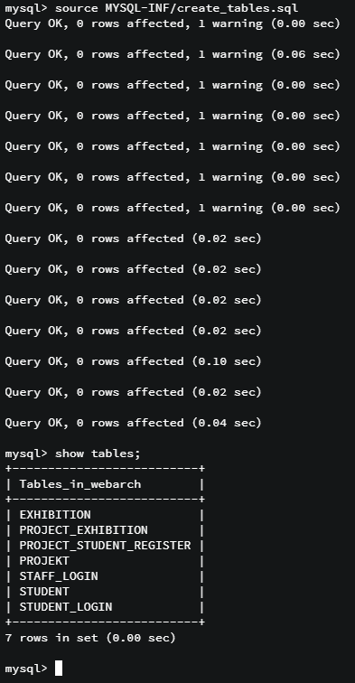

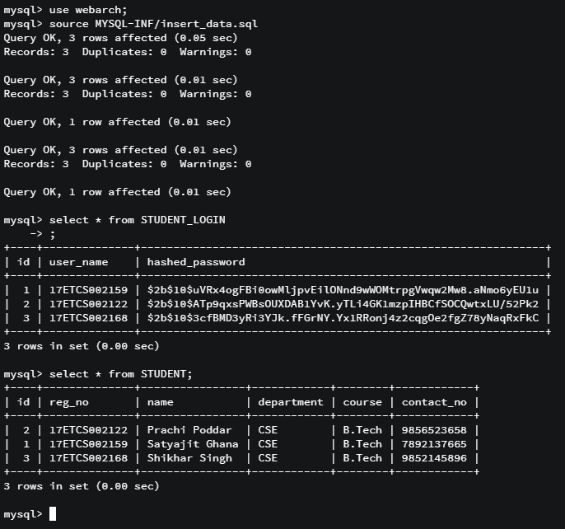

1. Analysis and Discussions
2. Conclusions
3. Comments

a. Limitations of Experiments

b. Limitations of Results

c. Learning happened

d. Recommendations

|  |  |  |
| --- | --- | --- |
| **Component** | **Max Marks** | **Marks Obtained** |
| **Viva** | **6** |  |
| **Results** | **7** |  |
| **Documentation** | **7** |  |
| **Total** | **20** |  |